Virtual Initio Programming: Debugging

AIM: After completing this worksheet you should be able to identify problems in programs based on error messages and use the IDLE debugger.

You Need: To complete this worksheet you need to have a virtual Initio simulator (see WS1), and to be able to use files to store Programs (WS5). You also need to know the commands to operate the Initio motors and sensors (WS3 & WS4). You should be able to use If statements (WS7), while loops (WS8 & WS10), variables, numbers (WS12) and strings (WS13) in Python programs.

If the simulator isn’t already running: Start the Simulator, Select the Initio Simulation and default_world.xml, then start IDLE (open a new IDLE window if you have used IDLE to start the simulator).

You have written a number of programs by now and so are probably already familiar with some of the error messages you might get.

Consider the following program. It contains an error:

import simclient.simrobot as initio

initio.init()

direction = input(["Which way would you like the robot to move? (F, B, L, R)"])

while(direction != "S"):
if (direction == "F"):
initio.forward()

elif (direction == "B"):
initio.reverse(10)

elif (direction == "L"):
initio.spinLeft(10)

elif (direction == "R"):
initio.spinRight(10)

direction = input(["Which way would you like the robot to move next? (F, B, L, R, S)"])

initio.stop()

If you run this program and type F as input you should see the following error message:

Traceback (most recent call last):
File "/Users/louisedennis/PiRovers/pirover_simulator/examples/tmp2.py", line 12, in <module>
initio.forward()
TypeError: forward() missing 1 required positional argument: 'speed'

Read the error message carefully.

Question 1: On what line has the error occurred?

Question 2: What does the error message say is missing from forward() ?

An argument is something that goes in the brackets. You can fix this program by putting something in the brackets for forward().

Correct the program and and check that it works:

Debuggers

Sometimes problems in programs can not be found simply by looking for a syntax error. Many programmers use print statements to help them understand what their program is doing and what the values of variables may be but there is a better way to do this and that is by using a debugger. There are a lot of different debuggers and each one works differently key features however are

- Code stepping a debugger will let you execute a program one command at a time. This will let you see what is happening at each stage of the program, which branches of if statements are being used and similar things.
- Breakpoints in long programs simply stepping through every instruction can get tiresome, particularly if you know that the error doesn’t occur until later in the program. Debuggers will let you set a breakpoint in your code and then execute the program until the breakpoint is reach at which point you can start stepping through the code.
- Inspecting Variables Debuggers let you see what the values of variables are which can help you figure out what is going wrong.

We are going to look at the debugger that comes with IDLE.

To start the debugger you should click on the Debug menu in IDLE’s Python Shell window and select Debugger. A window a bit like the following should appear and the words [DEBUG ON] will appear in the Shell window.

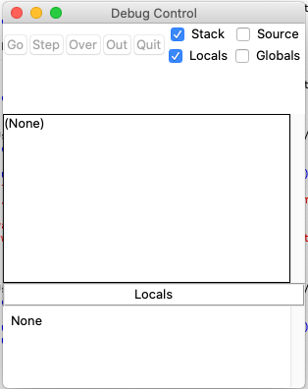
The Debugger Window
Run the Python Program you have been working on. You will notice that it doesn’t run, but a lot of information appears in the Debugger window such as __file__ showing the file name. The five buttons Go, Step, Over, Out and Quit are available.

Question 3: Click on Go. What happens?

Stop the program either by selecting S when prompted by the program.

Now run the program again and this time click Over instead. Over lets you step through each line in the program (we will discuss the use of Step) in a later tutorial.

In the top part of the debugger window you can see the line of code that the debugger is currently at – for instance

- ‘__main__’.<module>(), line 9: while(direction != “S”):

Is at line 9 of the program – the command while(direction != “S”):

The bottom part of the debugger window contains values of variables like direction.

Step through the code entering all the different letters F, B, L, R, S as prompted by the program.

Question 4: How many times do you have to click Over?

Qeustion 5: Run the program again and click Over a couple of times and then click Go. What happens?

Lastly we will look at how to set a breakpoint. In the program right click on the line

elif (direction == "L"):

and select Set Breakpoint. The line should go yellow.

Question 6: Now run the program and click Go. Enter R when prompted by the program. What happens?

Question 7: What line have you stopped at?

Question 8: What is the value of direction?

University of Liverpool, 2019
This work is licensed under a Creative Commons Attribution-NonCommercial-ShareAlike 4.0 International License.

