Programming in Python with the Initio Simulator: Part 1

Chapter 1: Getting Started
AIM: After completing this chapter you should be able to start the virtual Initio simulator and change the simulation environment for the virtual robot by adding and removing boxes, lines and light sources.

Before you start: You need to have installed our simulator somewhere. It should be in a folder called pirover_simulator. You will find the simulator in this folder. It is called pysim.py (Windows and Linux) or pysimosx.py (Macs).

To start you need to run the simulator. You can run it either from the command line or from IDLE.

From the Command Line (Windows and Linux): Type python3 pysim.py then press return.

From the Command Line (Macs): Type python3 pysimosx.py then press return.

From IDLE: Start IDLE. A window will open and you should see something like:

Python 3.7.2 (v3.7.2:9a3ffc0492, Dec 24 2018, 02:44:43)
[Clang 6.0 (clang-600.0.57)] on darwin
Type "help", "copyright", "credits" or "license()" for more information.
>>>

Open pysim.py (pysimosx.py on Macs) from the File Menu.
This file will open in a new IDLE window, including a new menu item Run.
From Run, select Run Module.

You should see: You should see: 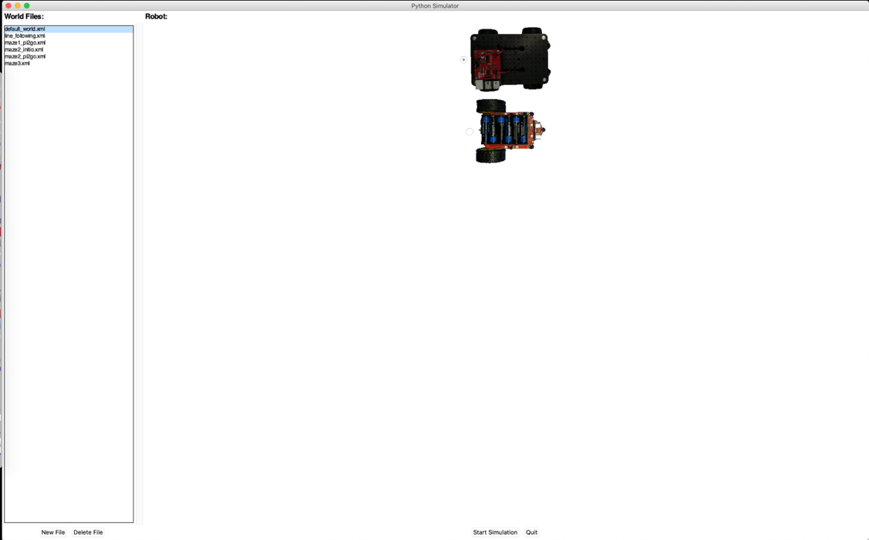

From here you can start a simulation for either the Initio robot (the top image) or the Pi2Go robot (the bottom image) in a number of settings (the “World Files” on the left).

Select the Initio robot and the default_world.xml.
Then click on Start Simulation

Once the simulation has started, you can stop it by clicking Close in the Pi2Go window.

You can exit the simulator by clicking Quit.

Opening the Edit Window

You can change the environment your virtual Pi2Go encounters by using objects from the Edit window.

Click on Edit in the Pi2Go Simulator. A second window, the Objects window, should open as shown in the screenshot below

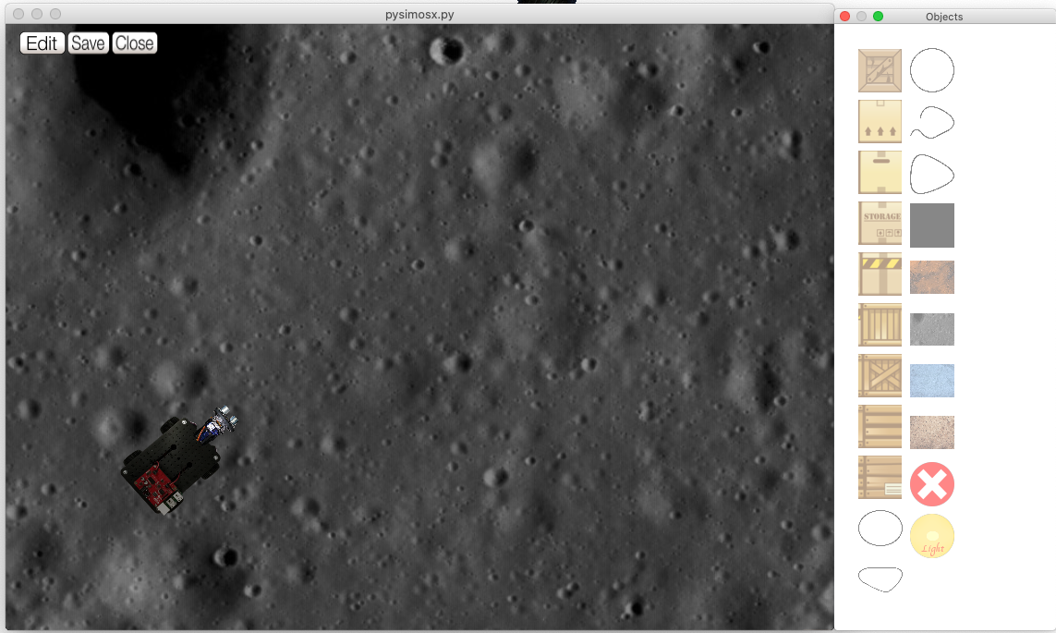

The Objects Window contains 8 blocks, 5 lines, a Black Square, 4 backgrounds, a Delete button and a Light source.

- Select the Objects Window

- Click on the top block

- Select the Simulation Window
- Right click somewhere.

Question 1: What happens?

- Select the Objects Window

- Click on the Delete Button

- Select the Simulation Window

- Right click on the Block

Question 2: What happens?

- Select the Objects Window

- Click on the Black Square

- Select the Simulation Window
- Right click somewhere
(the Black Square should appear)
- Left click on the Black Square in the Simulation Window
and use the mouse to drag it around.

Question 3: If you drag the Black Square to the same space as the robot does it appear over or under the robot?

Add a block object and drag it around with the mouse.
Question 4: What happens when the block is dragged over the robot?

Try adding and removing and moving:

- Lines
- Backgrounds
- Light Source

Question 5: Can backgrounds be moved by clicking and dragging? YES/NO
Question 6: How do you move the ray of light from the Light Source?

When you have altered a world you can save it by clicking Save but you will need to change its name.

When you want to exit the simulator, select click Close in the Pi2Go world window, followed by Quit in the simulator window.
Chapter 2: Command Lines
AIM: After completing this chapter you should be able to start and stop the IDLE integrated development environment and use simple commands.

You Need: To complete this worksheet you need to have access to IDLE.
You should have the virtual simulator running and have selected the Initio robot and the default_world.xml world (chapter 1).

For simple programming tasks we can use the Python Command Line Interpreter. We are going to use this from within an integrated development environment called IDLE.
Start IDLE (if you already have IDLE running for the simulator you should start a new IDLE window for programming the virtual robot).

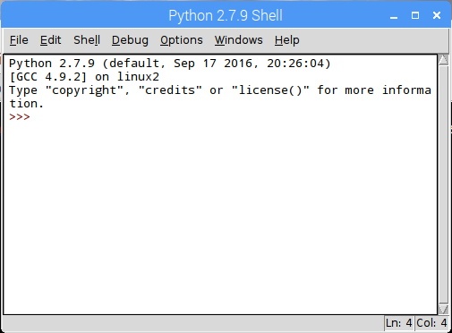

3 signs (>>>) are called the prompt

The Python Command Line Interpreter in IDLE

You should now be in the Python Interpreter which should look like the above. You DO NOT need to type the “prompt” (>>>) before any python commands.

print(“Hello World”)
followed by Return.
Question 1: What happens?

We will now try to import a module for our Initio robot.

Type

import simclient.simrobot as initio

followed by Return.

IMPORTANT: if you get an error at this point that says

ModuleNotFoundError: No module named 'simclient.simrobot'

Then you need to add the simulator to your PYTHONPATH. To do this see the box at the end of this worksheet.

open the file setup_programming.py using the File menu (you will find setup_programming.py in the pirover_simulator folder). Once this file is open select Run Module from the Run menu.

This will print the path to the simulator directory. You can ignore this for now, but will need it when you start using files for your programs.

Then try

import simclient.simrobot as initio

followed by Return.

Now type the following commands one after another, each followed by Return.

initio.init()
MOVE
MOVE
initio.forward(10)
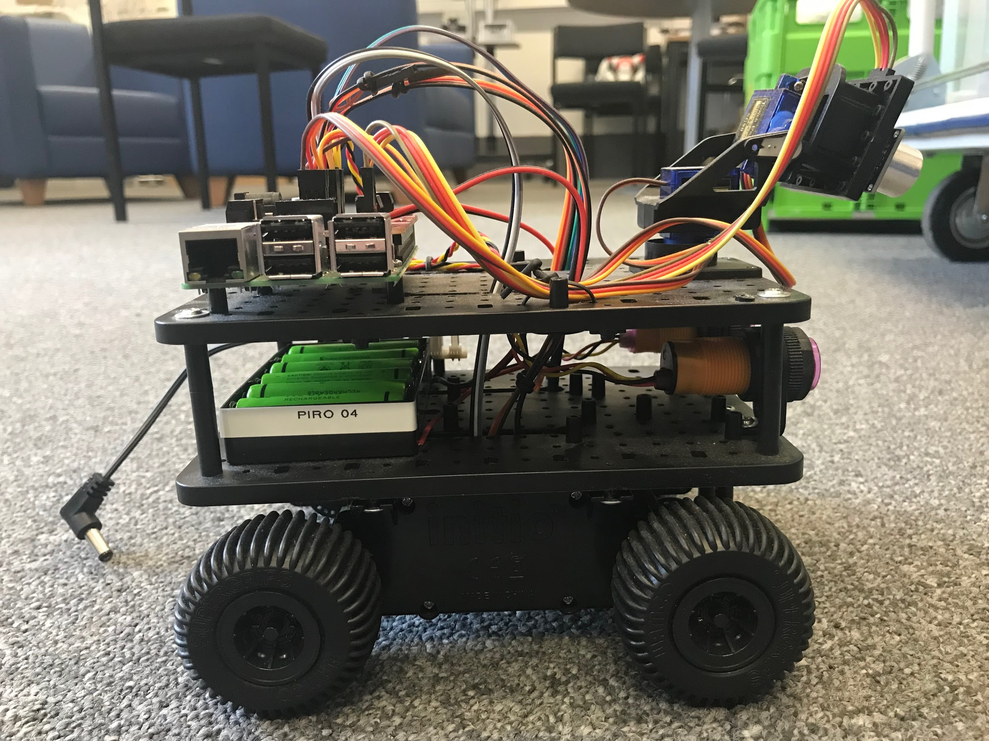
initio.stop()

Question 2: What happens?

You can use alt-p (pressing the Alt key and P at the same time) to scroll back through previous commands.

Try replaying some commands using alt-p

You will learn more about controlling the Initio robot from the Python Command Line in worksheet WS3.

If you have finished working with your robot type:

initio.cleanup()

Otherwise carry on to chapter 3.

Chapter 3:
Python Statements and Pi2Go Commands
AIM: After completing this chapter you should be able to control your Initio simulation using simple statements issued at the Python Command Line and be able to explain what a statement in a programming language is.

You Need: To complete this worksheet you need to have a virtual Initio simulator (see chapter 1), and understand how to control the virtual Initio from the IDLE command line (see chapter 2).

If the simulator isn’t already running:
Start it (see chapter1), and select the Initio robot and default_world.xml. Now open a new IDLE window.

Remember: You can scroll back through commands in IDLE by typing alt-p

In order to control your robot simulation, you need to initialise it properly.
To initialise your simulation, type the following at the Python Command Line

>> import simclient.simrobot as initio
>> initio.init()

Now you can use simple commands to control your simulated robot. Try typing the following:

>> initio.forward(20)
>> initio.stop()
Question 1: What happens?

Each of these commands initio.init(), initio.forward(20), initio.stop() is a python statement. Statements are the basic commands that are used to build up programs. You have several commands available to you for operating the Initio robot.

These commands are described in the box on the next page. Not that parts in italics are inputs to the commands which you have to select. So for initio.spinLeft(speed) you have to replace speed with a number between 0 and 100.
initio.stop()
initio.forward(speed)
where speed is a number and 0 <= speed <= 100
initio.reverse(speed)
where speed is a number and 0 <= speed <= 100
initio.spinLeft(speed)
where speed is a number and 0 <= speed <= 100
initio.spinRight(speed)
where speed is a number and 0 <= speed <= 100
initio.turnForward(leftSpeed, rightSpeed)
where leftSpeed and rightSpeed are numbers and
0 <= leftSpeed, rightSpeed <= 100
initio.turnReverse(leftSpeed, rightSpeed)
where leftSpeed and rightSpeed are numbers and
0 <= leftSpeed, rightSpeed <= 100
initio.setServo(servo, angle)
where servo is either 0 or 1 and -90 <= angle <= 90

Try typing the following:

>> initio.setServo(1, 45)

Question 2: What happens?

initio.setServo controls two servo motors that move the sensor at the front of the robot. It takes two inputs: the number for the servo (0 is for tilt which moves the sensor up and down. 1 is for pan which moves the sensor from side to side), followed by the angle in degrees you want to move it to (where 0 means it is pointing forwards dead centre). So the command you just typed gets the servo to pan 45 degrees to the right from the centre point.

Unfortunately, the virtual Initio doesn’t have a tilt servo so you can not use the command to tilt the sensor.

You will learn more about sensors in chapter 4.

Question 3: Try four of the other commands from the table. What do they do?

Command Result

Remember: When you have finished working with your robot type:

initio.cleanup()

When you want to exit the simulator, select the simulator window and type Q.

Chapter 4: Sensors
AIM: After completing this chapter you should be able to describe the sensors on the Initio simulation and use Python to get information from them.

You Need: To complete this chapter you need to have to have a virtual Initio simulator (see chapter 1), understand how to control it from the IDLE command line (see chapter 2), and how to control the pan/tilt servos (see chapter 3).

If the simulator isn’t already running:
Start it (see chapter 1) and select the Initio robot and default_world.xml. Now open a new IDLE window.

An Initio robot has two different kinds of sensors:

- Ultrasonic: It has an ultrasonic sensor which uses sound and echoes to measure distances.

- Infrared: It has several infrared sensors that measure how much infrared light is reflected. These can be used both to measure distances (like with the ultrasonic sensor) and to measure colour – for instance a black surface reflects less infra-red light than a white surface.

These sensors are all simulated on your virtual Initio and you can use Python to get values from the sensors.

The Ultrasonic Sensor

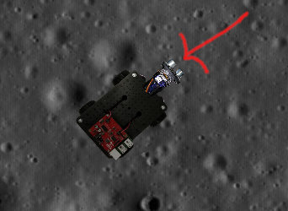
The Ultrasonic Sensor

Locate the ultrasonic sensor on your virtual Initio.

There is one command you can use to get information from the ultrasonic sensor. This is:

>>> initio.getDistance()

initio.getDistance() returns the distance in cm to the nearest reflecting object. A value of zero means it does not detect an object

Type initio.getDistance()
Question 1: What value do you get?

Let us put something in front of the virtual Initio.
Type E anywhere in the Simulator Window to open the Objects window and place one of the blocks in front of the Initio’s distance sensor.

Try getting the distance using the Python command.
Question 2: What value do you get?

Now try moving the object closer to the sensor, using the mouse to click and drag it.
Question 3: What value do you get?

The ultrasonic sensor is the sensor you can move using the initio.setServo command discussed in chapter 3.
Move your block a little to one side of the ultrasonic sensor.
Use initio.setServo to move the sensor and see what difference it makes to the result from initio.getDistance()
Question 4: What command(s) did you type to move the sensor in order to detect the object?

Infrared Sensors
The Initio’s infrared sensors are organised into two groups: sensors for detecting obstacles and sensors for detecting lines.
There are two sensors for detecting obstacles at the front of the robot:
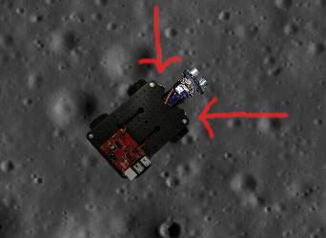
The locations of the InfraRed Obstacle Sensors
There are three commands for getting information from the obstacle sensors:
>>> initio.irLeft()
returns 1 (meaning True) if the Left IR Obstacle sensor detects an obstacle
and 0 (meaning False) otherwise
>>> initio.irRight()
returns 1 (meaning True) if the Right IR Obstacle sensor detects an obstacle
and 0 (meaning False) otherwise
>>> initio.irAll()
returns 1 (meaning True) if either of the Obstacle sensors detects an obstacle
and 0 (meaning False) otherwise

Using the Objects Window place blocks so that initio.irAll()returns 1.
Question 5: How many blocks did you need?

The Initio’s other infrared sensors are used to detect how dark the colour of the surface the robot stands on is. These are referred to as “line sensors” since their primary use is for detecting black lines on white surfaces.
There are two line sensors.
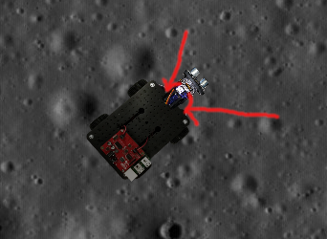
The Line Sensors
There are two command for getting information from the line sensors:
>>> initio.irLeftLine()
returns the state of Left IR Line sensor
>>> initio.irRightLine()
returns the state of Right IR Line sensor
In the Objects Window select the Black Square and place it under the front of the robot.
Question 6: What do the python commands return if the Initio is over the black square?

Quesiton 7: What do they return if the Initio is over the background?

Remember: If you have finished working with your robot type:

initio.cleanup()

Chapter 5: Worlds
AIM: This exercise sheet provides additional activities for investigating the Initio robot sensors. It assumes familiarity with the material in chapter 1-4.

Exercise 1: So far we have used our Initio simulation only in default_world.xml.
For this exercise we will look at a different world.

If the simulator is currently running you need exit default_world.xml (by clicking on close) and disconnect your virtual Initio robot by typing initio.cleanup() in the IDLE window where you have been doing the previous exercises.

Open maze1.xml. In the IDLE window where you have been doing the exercises, reconnect your virtual initio by typing initio.init();

Question 1: What are the values returned by the ultrasonic sensor and the two infrared distance sensors in this world?

Drive the Initio using the motor commands to another part of the world and take new values for the ultrasonic and infrared sensors.
Question 2: What happens if the Initio hits one of the blocks?

Exercise 2: Move the robot so that it is facing a block square on like in the picture below.
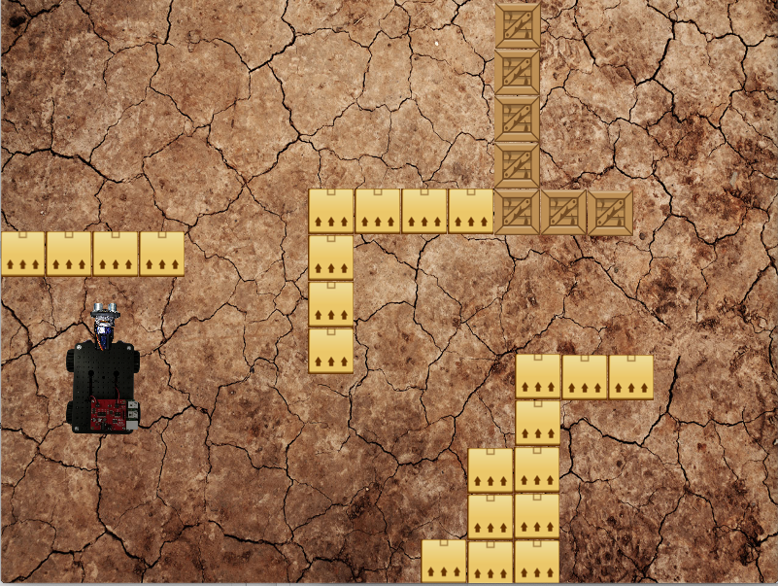

Now pan the ultrasonic sensor through every angle from -45 to 45 and record the value it returns.

Question 3: Can you explain the differences in all these values?

Exercise 3:
Exit maze1.xml and disconnect your virtual Initio robot by typing initio.cleanup() in the IDLE window where you have been doing the exercises.

Open linefollowing.xml. In the IDLE window where you have been doing the exercises, reconnect your virtual Initio robot by typing initio.init()
Question 4: What are the values returned by the two infrared line sensors in this world?

Move the robot backwards and forwards until you find a spot where the two infrared line sensors both return 1 (NB. this can be a bit tricky).

Chapter 6: Programs in Files
AIM: After completing this chapter you should be able to write a Python program using IDLE’s program editor and execute it in IDLE.

You Need: To complete this worksheet you need to have a virtual Initio Simulator (see chapter 1).

If the simulator isn’t already running:
Start it (see chapter 1) and select the Initio robot and default_world.xml. Now open a new IDLE window.

You can control your virtual Initio by writing commands at the Python command line. However, for longer programs, or programs you wish to run several times this can become tedious. To get around this you can write a Python program in a file.

We are going to consider the following Python program

import simclient.simrobot as initio

initio.init()

initio.forward(10)
initio.setServo(0, -45)
initio.stop()

To write this program we are going to use the editor that comes with IDLE.

Select File > New File in IDLE.

Type the program above into this file (make sure you spell everything correctly).
You can save the file using the File menu. We suggest you create a folder for your Python programs.

You can execute your program by selecting Run > Run Module
Question 1: Try this now. What happens?

If you are lucky this will have run smoothly.

IMPORTANT: if you get an error at this point that says

ModuleNotFoundError: No module named 'simclient.simrobot'

Then you need to add the simulator to the python path called by the file. Open the file setup_programming.py using the File menu (you will find setup_programming.py in the pirover_simulator folder). Once this file is open select Run Module from the Run menu.

This will print out the path to the pirover_simulator.

At the top of your file you now need to add the lines

import sys
sys.path.append(path_to_simulator)

Where you replace path_to_simulator with the path that was printed when you ran setup_programming.py

If the file doesn’t run smoothly (and you don’t have a path problem as described in the box above), you should have received an error message and will need to check your program for spelling errors.

Exercise 1: Modify your program so that it pans the ultrasonic sensor to 45 degrees first, and then moves it back to 0 after the Pi2Go has stopped.

Remember: When you have finished working with your robot type:

initio.cleanup()

When you want to exit the simulator, select the simulator window and type Q.

Chapter 7: The Time Module
AIM: After completing this worksheet you should be able to use commands from Python’s Time module to delay execution of commands on the Initio. You should also be able to explain how to import a module into Python.

You Need: To complete this worksheet you need to have a virtual Initio Simulation (see chapter 1), and to be able to use files to store Programs (see chapter 5). You also need to know the commands to operate the virtual Initio motors (see chapter 3).

If the simulator isn’t already running:
Start it and select the Initio robot and default_world.xml. Now open a new IDLE window.

When we program, we don’t always want to write everything the program should do from scratch. When someone has already solved a problem, for instance delaying the execution of a command, then we would like to be able to use their solution. This is done by importing modules (in some languages called libraries) of pre-programmed commands into our program.

You are already using a module in your programs.
The statement import simclient.simrobot as initio at the start of all your programs is importing the simulation module which contains the commands for operating your virtual Initio robot, and renaming this module initio.

In this worksheet we will use the time module to delay the execution of some of those commands.

Create a file containing the following program and execute it:

import simclient.simrobot as initio, time
initio.init()

initio.forward(10)
time.sleep(10)
initio.stop()

Question 1: What happens?

The Sleep Command The command time.sleep(seconds) makes the program pause for the number of seconds before executing the next command.

Exercise 1: Adapt the program to make the robot move forward for 20 seconds before stopping.

Question 2: What did you change?

Exercise 2: Write a program to make the robot wait for 30 seconds, move forward for 10 seconds, turn for 10 seconds and then stop.

.
Chapter 8: Simple Programs
AIM: This chapter provides additional simple programs for you to write for your virtual Initio. It assumes familiarity with chapters 1-7.

Exercise 1: Write a program that will spin the robot for 2 seconds, then take a distance sensor reading and print it to the screen and stop.
To print the value of the sensor use: print(initio.getDistance())

Exercise 2: Write a program which will make the robot pan its ultrasonic sensor right for 5 seconds, then left for 5 seconds and then return it to the centre.

Exercise 3: Write a program so that your robot drives around in a circle taking readings from its two infrared distance sensors roughly every quarter circle. Some experimentation will be needed to work out how long a quarter turn takes for your robot.

Exercise 4: Write a program where the robot moves forward changing speed every 10 seconds for a total of 30 seconds.

Exercise 5: Write a program so that the robot shakes its head (pans its ultrasonic sensor left and then right as in exercise 2). Then it moves forward for 10 seconds and shakes its head again. Then it spins on the spot for 10 seconds and shakes its head again. Then it reverses for 10 seconds and shakes its head a final time.

Exercise 6: Exit the default_world.xml (by pressing Close) and disconnect your virtual Initio robot by typing initio.cleanup() in the IDLE window where you have been doing the previous exercises.

Now open maze1.xml. In the IDLE window where you have been doing the exercises, reconnect your virtual initio by typing initio.init();

Write a program that will move your robot from the start position to the top right hand corner (without you clicking and dragging the robot). To do this you will need to experiment to find out how long it needs to move forward in each stage and how long it needs to turn for in each stage.

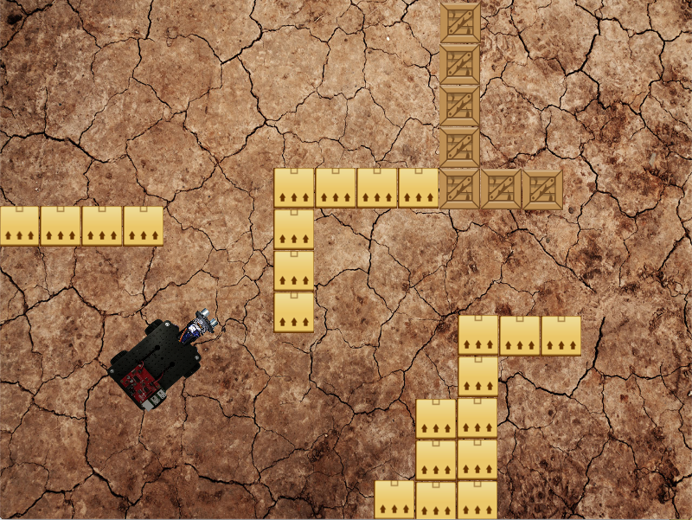
Move the robot from the position on the left to the position on the right.

.
Chapter 9: If
AIM: After completing this worksheet you should be able to use if, elif and else statements in Python to create more complex programs.

You Need: To complete this worksheet you need to have a virtual Initio simulation (see chapter 1), and to be able to use files to store programs (see chapter 6). You also need to know the commands to operate the virtual Initio motors and sensors, and the time.sleep command (see chapter 3, 4 and 7).

If the simulator isn’t already running:
Start it, and select the Initio robot and default_world.xml. Now open a new IDLE window.

We want programs to be more flexible than simply following a series of instructions. We might want them to do different things in different circumstances. For instance, we might want our Initio robot to move backwards if there is an obstacle in front of it and forwards otherwise.

The following program will do this:

import simclient.simrobot as initio, time
initio.init()

if (initio.getDistance() < 50):
print(initio.getDistance())
initio.reverse(10)
else:
initio.forward(10)

time.sleep(10)
initio.stop()

There are a few things to note here. Python uses spaces to tell when something is part of a block of code inside an if statement. This feature is unique to Python and is not used in many other programming languages.

So in the program above, Python knows that it should print out the value from the ultrasonic sensor and then execute initio.reverse(10) if there is an obstacle closer than 50 cm, because these statements follow after the if and are indented.

Similarly it knows that initio.forward(10) should be executed if there is no obstacle because it follows after the else and is indented.

Note also that we have colons after the if and the else.
Question 1: Create a file containing this program and execute it. What happens?

Exercise 1: Describe how you would test your program to make sure it was working correctly both when there was an obstacle and when there wasn’t.

Question 2: Perform your tests. Is your program working correctly? YES/NO

Exercise 2: Write a program using an if statement that will turn in one direction if there is an obstacle on the right and turn in the other if there is an obstacle on the left.

Hint: To do this you may want to use elif which means (else if) - e.g.

elif (initio.irLeft()):

instead of else:

Question 3: How many cases do you need to consider to test your program?

Question 4: Does the description of the exercise tell you what the program should do in all cases? YES/NO

Exercise 3: Modify the program so that the robot reverses for 10 seconds if there is an obstacle and then turns for 10 seconds.
If there isn’t an obstacle the robot moves forward.

Chapter 10: While Loops
AIM: After completing this chapter you should be able to use while loops in Python programs.

You Need: To complete this chapter you need to have a virtual Initio (see chapter 1), and to be able to use files to store programs (see chapter 5). You also need to know the commands to operate the Initio motors and sensors (see chapters 3&4).

If the simulator isn’t already running:
Start it, and select the Initio robot and default_world.xml. Now open a new IDLE window.

A while loop allows a Python program to continue executing some statement multiple times while something remains true. For instance, we might want our Initio to keep reversing while there is an obstacle.

import simclient.simrobot as initio
initio.init()

initio.reverse(10)

while (initio.getDistance() < 10):
print(“Reversing”)

pi2go.stop()

Notice that we start reversing before we execute the while loop. This is because once you start your Initio moving, it carries on doing that until it is told to do something else. So, we are simply using the while loop prevent the program moving on to the stop command, until the obstacle is no longer detected.
Question 1: Create a file containing this program and execute it. What happens?

Question 2: What sort of tests would you need to perform to check the program was working properly in all cases?

.
Chapter 11: Using Logic in Conditions
AIM: After completing this chapter you should be able to use logic to construct more complex conditions for if and while statements.

You Need: To complete this worksheet you need to have a virtual Initio simulator (see chapter 1), and be able to use files to store programs (see chapter 6). You also need to know the commands to operate the Initio motors and sensors (see chaptes 3 & 4) and how to use if and while statements in Python (see chapter 9 & 10).

If the simulator isn’t already running:
Start it, and select the Initio robot and default_world.xml. Now open a new IDLE window.

Problem: When you program a real Initio robot, it has to be connected to a keyboard and monitor which is very cumbersome. Ideally you want to have time after the program has started running to disconnect everything, before the robot starts to move.

Consider the program below

import simclient.simrobot as initio, time
initio.init()

while (initio.getDistance() > 50):
print(“Waiting”)

initio.setServo(1, 20)
time.sleep(1)
initio.setServo(1, 0)

Question 1: What do you expect this program to do?

Question 2: Execute the program. Did it do what you expected? YES/NO.

Exercise 1: Modify the program by adding a second while loop so that the Initio ultrasonic sensor continues to be panned to the side until something gets closer than 50cm to it a second time.

Logic in conditions: You can use logic to make the conditions of your Python while and if statements more flexible. The main logical operators are not, and and or.

We can use these to build up logical expressions so, for instance:

initio.irLeft() | returns True if the there is an obstacle on the Left.
not (initio.irLeft()) | returns True if there is not an obstacle on the Left.
(initio.irRight() or initio.irLeft()) | returns True if there is an obstacle on the Right or one on the Left.
(initio.irRight() and initio.irLeft()) | returns True if there is an obstacle on the Right and one on the Left.

Exercise 2: Modify your program so that if there is nothing closer to the robot than 5cm then the Initio moves forward. Then when something gets closer than 5cm, the Initio stops moving.

Question 3: What expression are you using in the condition (if statement)?

You can make conditions more and more complex by composing the logical operators.

Exercise 3: Create a program so that if there is no obstacle on the Left or the Right then the Initio goes forward. Then when there is an obstacle on either side the Initio stops moving.
Question 4: What expression are you using in the condition?

.

Chapter 12: More Loops

AIM: After completing this chapter you should be able to use break, continue and while True: in programs

You Need: To complete this chapter you need to have a virtual Initio simulator (see chapter 1), and to be able to use files to store Programs (chapter 6). You also need to know the commands to operate the Initio motors and sensors (chapters 3 & 4). You should be able to use If statements (chapter 9) and while loops (chapter 10) in Python programs.

If the simulator isn’t already running: Start the Simulator, Select the Initio Simulation and default_world.xml, then start IDLE (open a new IDLE window if you have used IDLE to start the simulator).

Loops are fundamental to programming. However, there are a few constructs that make them much more flexible and easy to use.

Break: The command break is used to “break out” of a while loop. It is normally used inside an if statement and will stop the loop without executing anything that comes after it.

Consider the following program

import simclient.simrobot as initio
import time

initio.init()

while (not initio.irLeft()):
if (initio.irRight()):
break
initio.forward(10)
time.sleep(10)

initio.stop()

Question 1: What does it do?

Continue: Continue is used to mean start executing the loop back from the beginning, skipping the rest of the code. An obvious use of continue is when you simply want a loop to execute until something happens.

Consider the following program

import simclient.simrobot as initio
import time

initio.init()

while (not initio.irLeft()):
continue

initio.forward(10)

while (not initio.irRight()):
continue

initio.stop()

Question 2: What does it do?

While True: Lastly we can use the construct while True: in order to create a loop that just keeps executing until someone presses Control-C to exit the program or a break statement is used.

Exercise 1: Write a program using while True: and break. Where the robot starts moving the left IR sensor detects an obstacle and then it stops.

Exercise 2: Write a program using break, continue, elif and while True that does the following.

- If there is something in front of both the right and left IR sensors the program and robot stop.
- If there is something in front of the right sensor the robot should spin left and print “spinning to avoid obstacle”
- If there is something in front of the left sensor the robot should spin right and print “spinning to avoid obstacle”
- Otherwise the robot should move forward and print nothing.
- Use only one print statement.
Chapter 13: Logic and Control
AIM: This chapter provides additional programs using logic, if statements and while loops for you to write for your virtual Initio. It assumes familiarity with worksheets 1-2.

Exercise 1: Write a program that will pan the “head” of the Initio to the left if there is an obstacle on the left and to the right if there is an obstacle on the right.

Exercise 2: Write a program that behaves as follows: When an obstacle is detected on the left the program starts printing out the value from the ultrasonic distance sensor. When an obstacle is detected on the right it stops printing the distance out.

Exercise 3: Extend your program from exercise 1 so it keeps moving the Initio head as obstacles appear and disappear.

Exercise 4: Write a program that will make the Initio reverse if there are obstacles on both the left and right side. Once the obstacles both disappear it should stop reversing.

Exercise 5: Write a program that will make the Initio move forward if there is no obstacle in front of it (determined using the ultrasonic sensor) or to either side. Once an obstacle appears somewhere it should stop moving.

Exercise 6: Adapt your programs from exercises 4 and 5 so that the robot reverses until there are no obstacles and then moves forward until there is an obstacle and keeps repeating this.

Chapter 14: Obstacle Avoidance

AIM: After completing this chapter you should be able to integrate your Python programming knowledge to create obstacle avoidance behaviour in a virtual Initio robot.

You Need: To complete this worksheet you need to have a virtual Initio simulator (see chapter 1), and to be able to use files to store Programs (chapter 6). You also need to know the commands to operate the Pi2Go motors and sensors (chapters 3 & WS4). You should be able to use Python control structures (chapters 9-12).

If the simulator isn’t already running: Start the Simulator, Select the Initio Simulation and default_world.xml, then start IDLE (open a new IDLE window if you have used IDLE to start the simulator).

Challenge: Implement obstacle avoidance behaviour on an Initio robot.

Designing the program: Before you can implement a behaviour, you should try to define what that behaviour involves. In this challenge we will define obstacle avoidance behaviour to mean: “The Initio should move forwards while there is no obstacle and should turn (either right or left) when there is an obstacle”.

We can illustrate this with a flow chart

Is there an obstacle?
Turn
Forward
Yes
No

Question 1: What sensor and motion commands do you expect to use for this challenge?

You can go ahead and attempt to write the program now – or you can follow the suggested steps below.

Step 1: Write a python program containing a while loop, which will make your Initio move forward while there is no obstacle and then stop when an obstacle appears. Test your program works.

Step 2: Extend your program so that you have a Python program that will move forward while there is no obstacle, then will turn while there is an obstacle, and then stops. Test your program works.

Step 3: Now you want to extend the program so instead of going around one while loop (while there is no obstacle) and then a second (while there is an obstacle) and then stopping, it instead repeats going around the two while loops. You can do this with a third while loop that contains the other two and which starts with while True:

Question 2: Write out how you are going to test that your program works.

Question 3: Execute your program. Does it work? YES/NO

Extending the Program: While you have successfully implemented obstacle avoidance behaviour, the behaviour of your program isn’t as nice as you might like. For instance, you have to use Ctrl-C to stop the program running and then stop the Initio at the Python command line.

Exercise 1: Extend the program so you can stop and start it easily by moving a block really close to the ultrasonic sensor (e.g. closer than 5cm). You might want to look at WS9 for hints about this.

Exercise 2: Write a program that will follow a line. You should use the same techniques you used to design and develop your obstacle avoidance program and use line_following.xml world to test the program. Your program design should involve the robot moving forward when its line sensors are either side of the line and turning left or right as appropriate if one of the line sensors detects the line. You will have to move the robot to a suitable starting position.

University of Liverpool, 2019
This work is licensed under a Creative Commons Attribution-NonCommercial-ShareAlike 4.0 International License.

